**Module 1**

***Business Communication, Management, and Success***

LO 1-1 Recognize myths about on-the-job writing.

LO 1-2 Distinguish business communication from other school writing.

LO 1-3 Explain accomplishments through communication.

LO 1-4 Understand costs for business communication.

LO 1-5 Define criteria for effective messages.

LO 1-6 Apply strategies for communication analysis.

LO 1-7 Apply strategies for creative thinking.

**Module Overview**

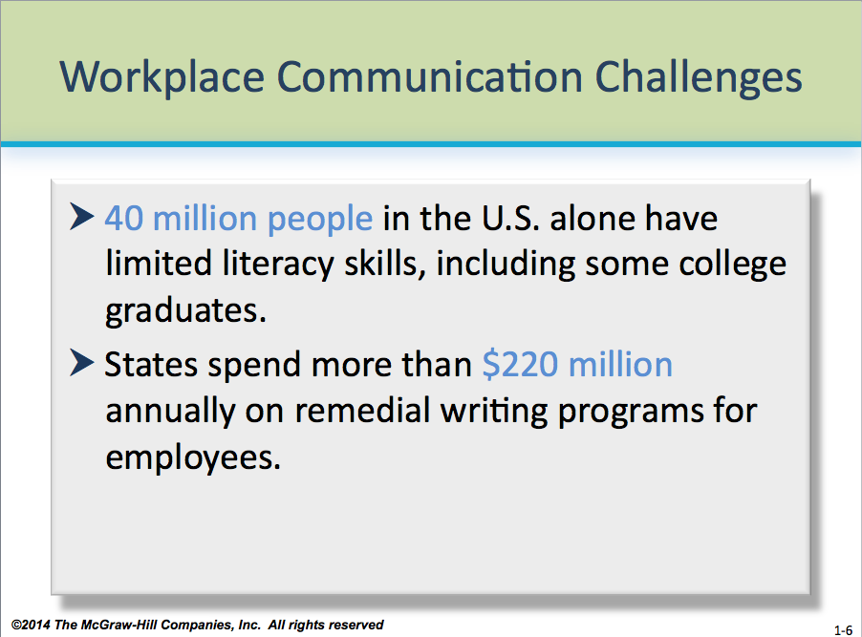Module 1 introduces students to the importance of writing in the workplace, dispelling myths about who writes and how. It also emphasizes that we live in a period of great change, especially as globalization continues to reshape the business world.

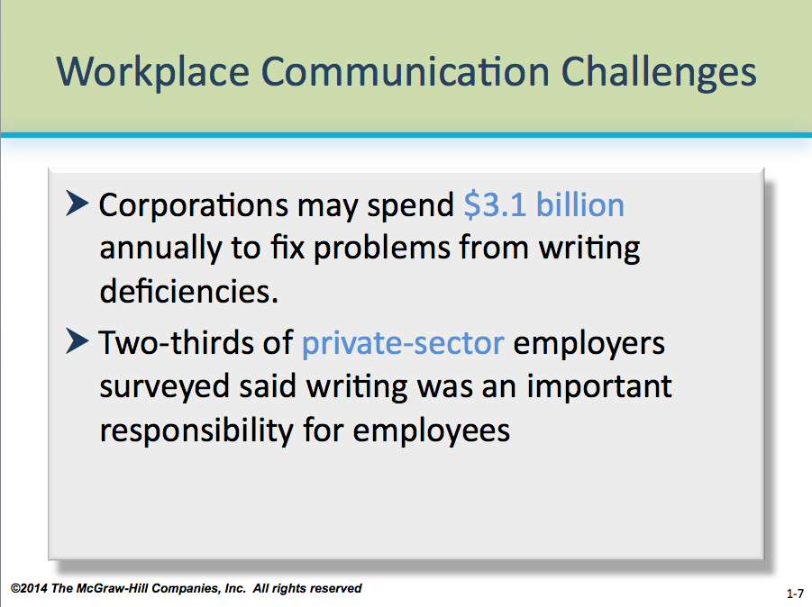Students can easily overlook the importance of writing to their careers—even people who are already in the workforce. In fact, a major complaint of many employers is that their prospective *and* current employees have poor or underdeveloped communication skills. Therefore, Kitty and Steve believe it’s vital to share with students early the realities of how important good communication skills are to the workplace.

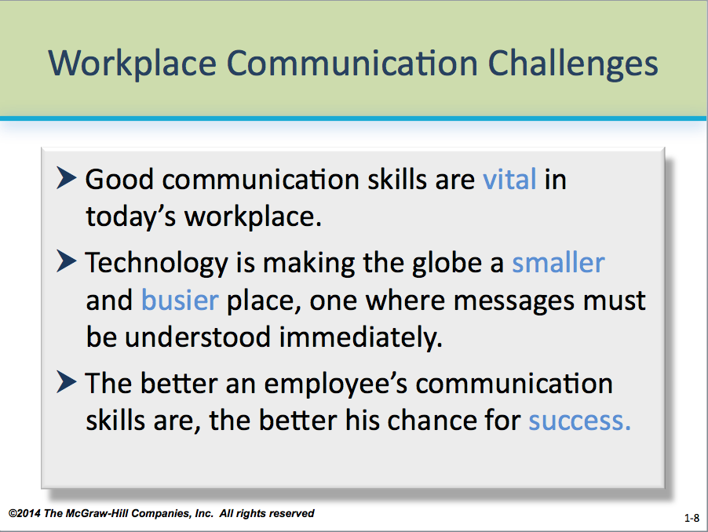As shown on **PP 1-6 through 1-8**, employers clearly want employees who communicate well, yet a staggering 40 million people in the U.S. alone have limited literacy skills, including some college graduates. According to a report by the College Board’s National Commission on Writing, states spend more than $220 million annually on remedial writing training for their employees, and corporations may spend $3.1 billion to fix problems from writing deficiencies. Globalization is changing where they are finding employees, millions of Americans are preparing to retire, and millions more will replace them—some with very different expectations for the workplace.

**☺** **Teaching Tip:** Many students are aware of a communication problem in the workplace that may have cost an organization time or money or both. Ask them to share stories about such problems, as well as how the organization compensated for the problems. Use **PP 1-6 through 1-8** to show the larger picture.

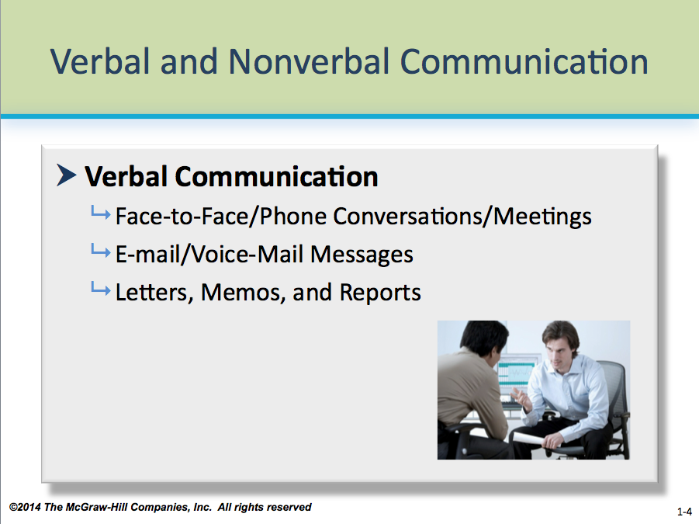

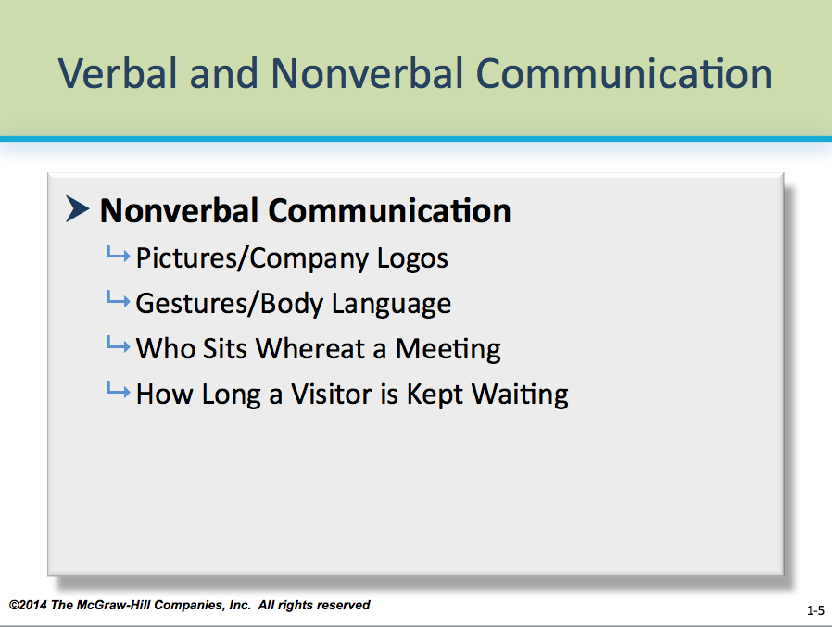Students may confuse the difference between verbal communication (which uses words) and nonverbal communication (which doesn’t). The fundamentals are on **PP 1-4 and 1-5.** The key point here is that we use a combination of verbal and nonverbal communication every day, on the job and otherwise. However, verbal and nonverbal techniques may differ not only from each other, but also from culture to culture, as expressed in **Module 3.**

As with all modules, Kitty and Steve recommend that you read Module 1 thoroughly before reviewing the discussion that follows.

**What’s in This Supplement**

This supplement is organized around the major questions posed in Module 1. It covers

**Part 1: Key Lecture Points, Teaching Tips, and In-Class Exercises Page 2**

**Part 2: Answers to Textbook Assignments Page 14**

**Part 3: Appendixes of Handouts/Transparency Masters Page 18**

**PowerPoint presentations** can be foundat our **Web page** at [www.mhhe.com/bcs6e](http://www.mhhe.com/bcs6e).

**Questions (with answers) suitable for quizzes and examinations** are in the ***Instructor’s Test Bank.*** For **student practice quizzes** with answers, see our **Web page.**

**Part 1: Key Lecture Points, Teaching Tips, and In-Class Exercises**

**Will I really have to write? LO 1-1**

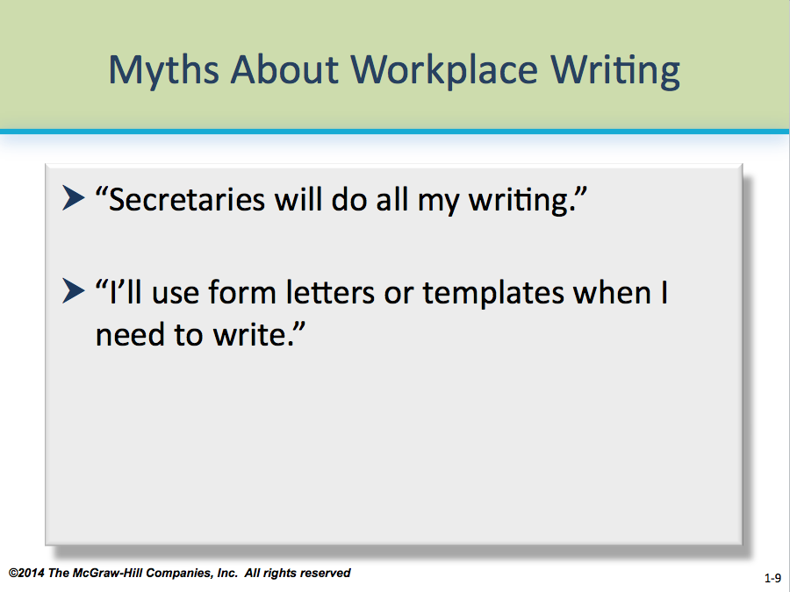 *Yes. A lot.*

Myths abound about writing on the job. Help students understand why learning business communication is important by addressing four common but generally flawed claims (outlined on **PP 1-9 and 1-10**):

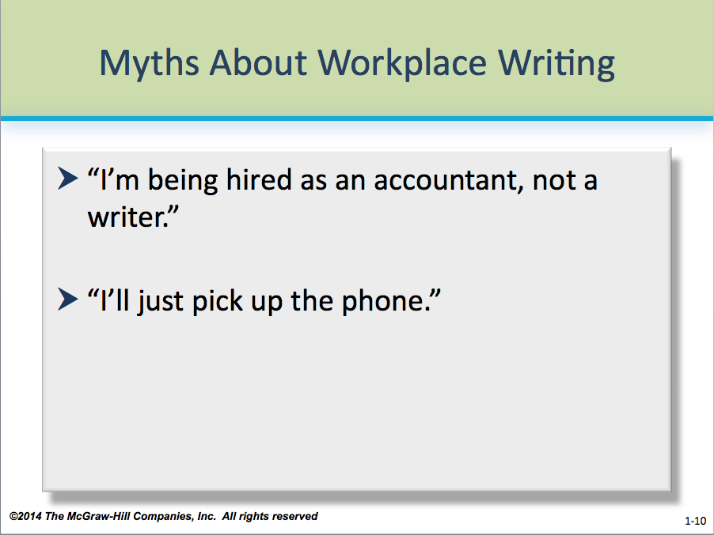**Claim 1:** Secretaries will do all my writing.

**Reality:** Because of automation and restructuring, secretaries and administrative assistants are likely to handle complex tasks such as training, research, and database management for several managers. Managers are likely to take care of their own writing, data entry, and phone calls.

**☺** **Teaching Tip:** Ask students who are secretaries or administrative assistants to share their experiences on this matter—how many of them do all of the writing for their bosses? Do any write for others in the organization? How much? How does this compare to the amount of writing others appear to do?

**Claim 2:** I’ll use form letters or templates when I need to write.

**Reality:** Using a form letter is OK if it’s a good letter. But form letters cover only routine situations. The higher you rise, the more frequently you’ll face situations that aren’t routine, that demand creative solutions.

** In-Class Exercise:** Have students bring to class form letters—a credit card pitch, a letter from a property owner, college correspondence, etc. —and critique them. Spend 10-15 minutes discussing the strengths and weaknesses of select letters. Do they “work”? Why or why not? How personal do they feel? Are the students emotionally attached to the service or product after reading the letters? How would this affect their decision to purchase?

**Claim 3:** I’m being hired as an accountant, not a writer.

**Reality:** Almost every entry-level professional or managerial job requires you to write e-mail messages, speak to small groups, and write e-mail and paper documents. People who do these things well are more likely to be promoted beyond the entry-level.

**☺** **Teaching Tip:** Have your students interview a friend or relative in the business world about how much writing he or she does on the job. In particular, the student should ask if the amount and type of writing is what that person expected to do. Tell the student to make a list of documents and, if possible, writing examples. Have students spend 10-15 minutes sharing their findings with the class.

**Claim 4:** I’ll just pick up the phone.

**Reality:** Important phone calls require follow-up letters, memos, or e-mail messages. People in organizations put things in writing to make themselves visible, to create a record, to convey complex data, to make things convenient for the reader, and so forth.

**☺** **Teaching Tip:** Have your students discuss what form of communication seems more “lasting” to them—phone or written correspondence. Which would they prefer for messages they consider important? Why?

**Don’t I know enough about communication? LO 1-2**

*Business communication differs from other school writing.*

Some students struggle to transition from what they’ve learned in previous writing courses, usually composition courses, to business communication. And because it’s likely they’ve taken several composition courses prior to business communication, they naturally want to apply composition strategies to your course.

Concepts may seem at odds with one another, even contradictory. For instance, while they were rewarded for broad, expressive writing in composition, business communication privileges brevity and less formal language. Argumentation may be less important than objectivity, precision, and completeness.

Students who apply other disciplines’ strategies indiscriminately often produce business documents that are wordy, confrontational, inappropriate in tone, or incorrect in format. Help them understand that all good writing shares some features—organization, detail, reason, and so forth—but business communication has expectations that are unique.

**☺** **Teaching Tip:** Novice writers often ignore distinctions between different disciplines of writing, such as *journalism, composition, fiction, business communication,* etc. Draw an analogy between these and disparate disciplines of mathematics—*algebra, geometry,* and *calculus*—or science—*biology, physics,* and *chemistry.* Explain that just as arithmetic forms the foundation of mathematical disciplines, so does the English language form the foundation of writing disciplines in the U.S. Differences make each discipline distinct, however, as distinct as in mathematics and science.

Use **PP 1-11** to illustrate the differences between school writing and business writing:

* 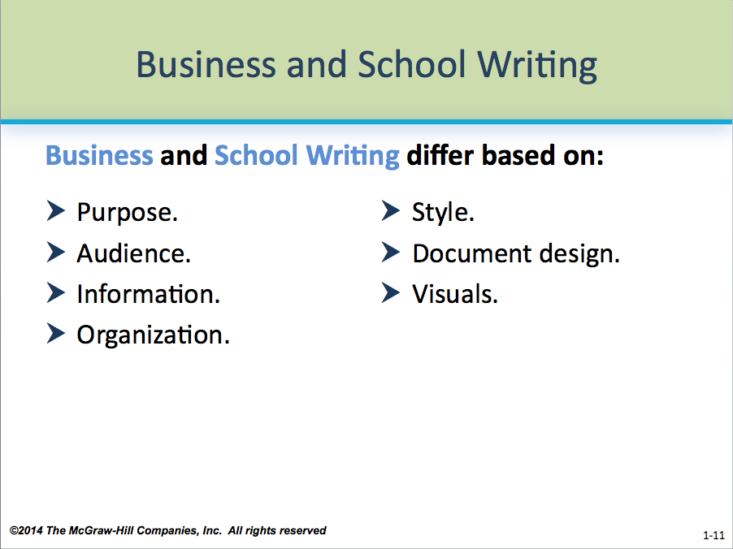Purpose
* Audience
* Information
* Organization
* Style
* Document Design
* Visuals

** In-Class Exercise:** Tell students to bring copies of compositions they’ve written to class. Have them spend 10-15 minutes analyzing them for purpose, audience, information, and so forth. Could the composition be adapted to a business message? What kind? How? What changes would have to be made? What qualities or features of the composition would not work?

**What does communication accomplish? LO 1-3**

*Management happens through communication.*

Managers aren’t the only ones who manage communication. Every day, workers must find ways to stay productive while juggling multiple tasks. Learning to manage communication is one way to keep things running smoothly. Learning the basics of business communication is a start.

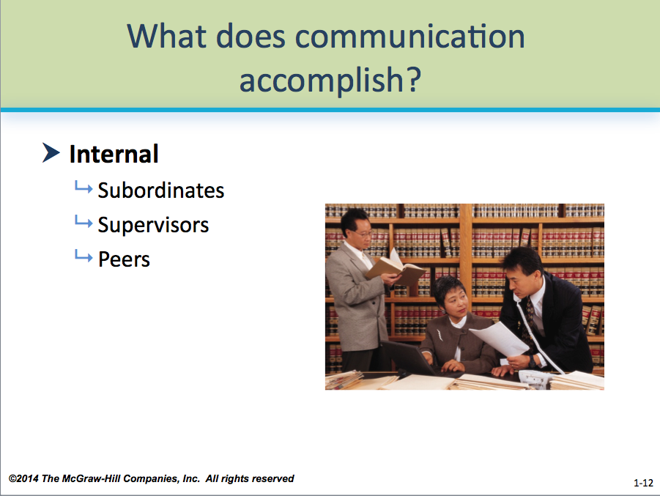As shown on **PP 1-12 through PP 1-15,** there are two broad categories of audience: internal and external. **Internal audiences** are other people in the same organization: subordinates, superiors, and peers. **Figure 1.1 (p. 7)** shows the internal audiences for a sales company.

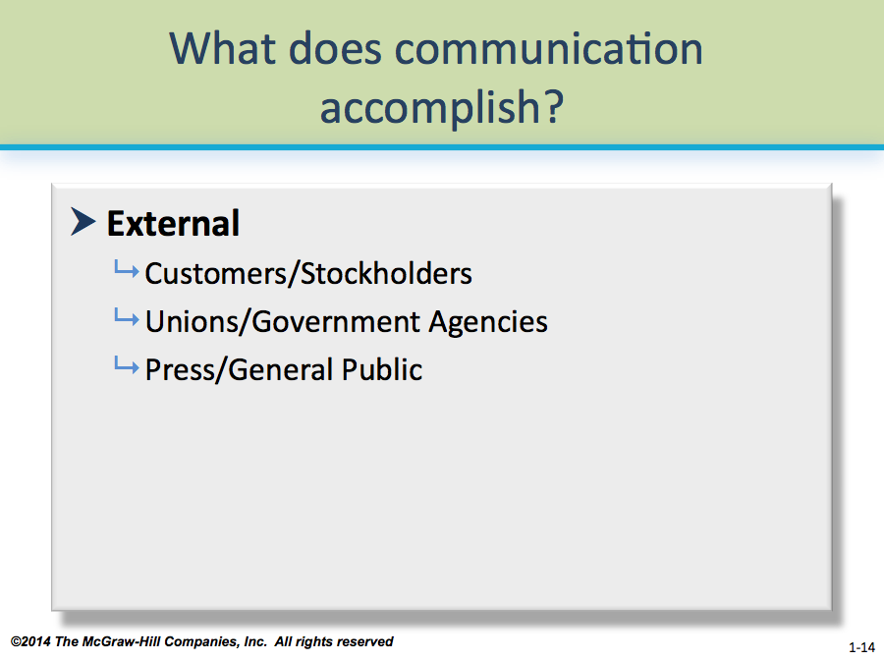**External audiences** are people outside the organization: customers, suppliers, unions, stockholders, potential employees, government agencies, the press, and even the general public. **Figure 1.2 (p. 7)** shows a corporation’s external audiences. (**Module 2** provides a more detailed breakdown of audience.)

Approaches to reaching these two audiences can be quite different—e.g., because internal audiences usually are more familiar, written correspondence may be more casual and in memo form.

** In-Class Exercise:** What do students perceive as the differences between internal and external audiences? Have them brainstorm for 10-15 minutes as a group on how these audiences are similar and how they are different. If students are writing to an internal audience, what document qualities would they be concerned about? For an external audience? In particular, ask students what would be similar or different about the following qualities: formality of language; use of humor; format of document (memo vs. letter); length; quality of paper, envelope (if any), and printing.

While memos, letters, and newsletters are more formalized ways of communicating in the workplace, the **grapevine** is the informal channel many employees rely on for information. Sometimes, employees will see the grapevine as more credible than “official” company organs, especially during periods of poor labor relations.

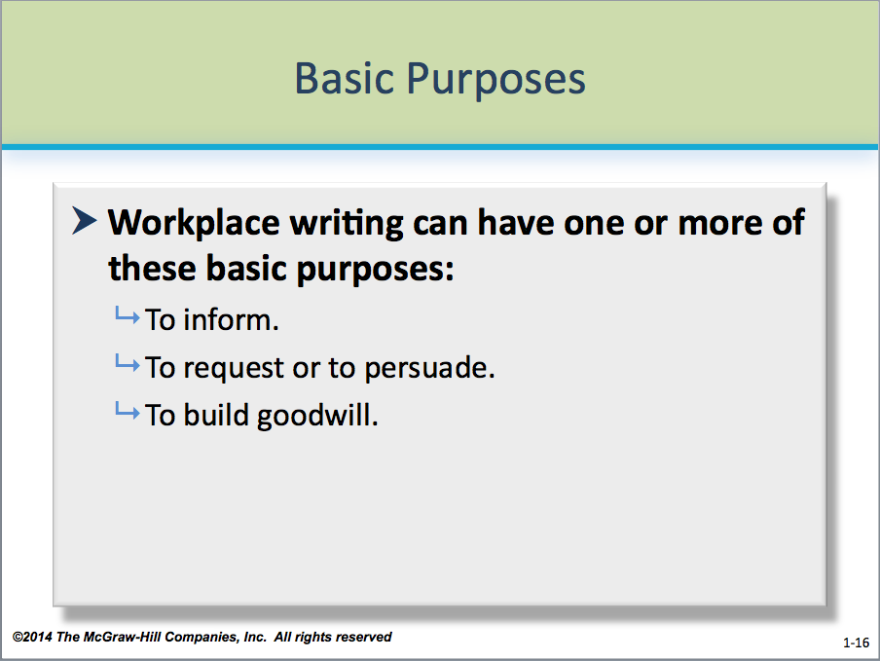**☺** **Teaching Tip:** Ask the students to share their experiences with a company or organization grapevine. Did they believe it more than information on company letterhead? Why or why not? How accurate was the grapevine? What effects did it have on organization morale and behavior? If the effect was poor, why did people privilege it?

As illustrated on **PP 1-16,** three basic purposes exist for writing in the workplace: **to inform, to request or persuade,** and **to build goodwill.**

**How much does correspondence cost? LO 1-4**

*$21.15 a page*—*even more if it doesn’t work.*

Unlike the “bottom line” for manufacturing and sales, the cost of writing in the workplace often seems incalculable or inconsequential to students. However, a consultant who surveyed employees in seven industries found that to prepare a one-page letter, most of them spent 54 minutes planning, composing, and revising the letter. According to the most recent figures from the U.S. Department of Labor, employers paid an average of $23.50 per hours per employee for wages and benefits. At that rate, an employer would pay $21.15 for an employee’s time spent writing a typical letter.

Help students understand that the true cost of poor communication generally isn’t measured in dollars and cents, but in the failure of the message to achieve its goals. Loss of credibility, failure to secure a job interview or get a promotion, a poor image of the organization, miscommunicated messages, and unresolved problems can result. Of course, ineffective communication can also translate into lost revenue.

*Document cycling* adds to the cost, as the same message might circulate back and forth among many people until the final version is produced. Researcher Geoffrey Cross found, for instance, that a one-page letter of transmittal for an insurance company annual report took 77 days to write because of document cycling. In the meantime, the dollar clock is ticking.

**☺** **Teaching Tip:** College course paper revisions are forms of document cycling between teacher and student that most students appreciate. Here students can learn while improving grades. Yet, there is also a cost: time. Ask students to analyze how much time they have spent re-writing a typical graded paper (not revising a paper *before* submission, a different task). Would they like to spend less? If so, what steps could they take to reduce the amount of time spent re-writing while improving the quality of their papers? How might they apply these steps to business documents? (You can tie this into PAIBOC, described below—how could students better analyze the writing problem *before* they start composing?)

Bad writing wastes time by

* Taking more time to read.
* Requiring more time to revise and causing more rounds of revision.
* Confusing ideas so that discussions and decisions are needlessly drawn out.
* Delaying action while the reader asks for more information or tries to figure out the meaning.

**What makes a message effective?** **LO 1-5**

*Good messages meet five criteria.*

Good business and administrative writing (illustrated on **PP 1-19**)

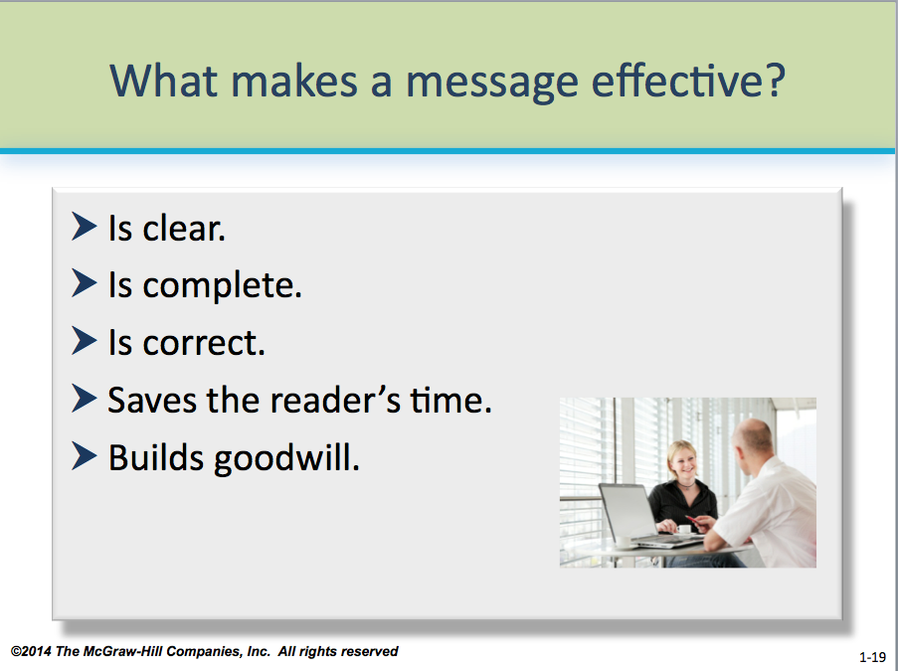

* Is clear.
* Is complete.
* Is correct.
* Saves the reader’s time.
* Builds goodwill.

Students should understand that while these are not the only qualities of good business writing, these five criteria form the foundation of all business messages.

For more information on building goodwill, see **Unit Two.**

**** **In-Class Exercise:** Tell students to bring copies of correspondence they’ve received that do not meet any or all of these five criteria. Have the students break into groups and spend 10-15 minutes identifying the problems with one of their group’s messages. What’s wrong with the message’s clarity or completeness? If the message did not save time, what went wrong? How did they feel about errors? What was the overall impression of the individual or organization that sent the message? Have the students spend another 10-15 minutes rewriting the portions they feel are problematic.

**How should I analyze business communication situations? LO 1-6**

*Try PAIBOC.*

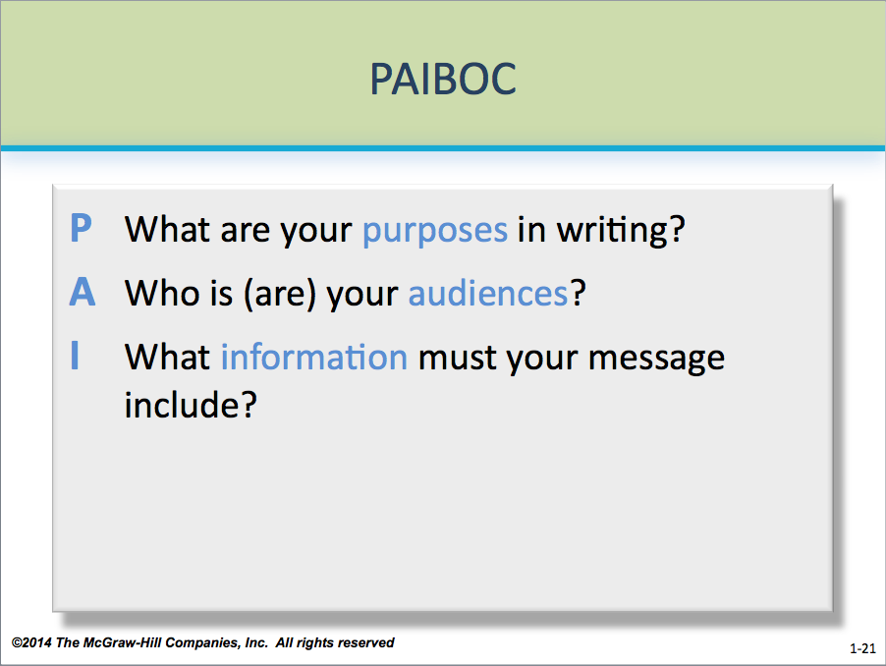

PAIBOC, as illustrated on **PP 1-21 and PP 1-22,** helps students to analyze business communication situations:

**P Purpose**

**A Audience**

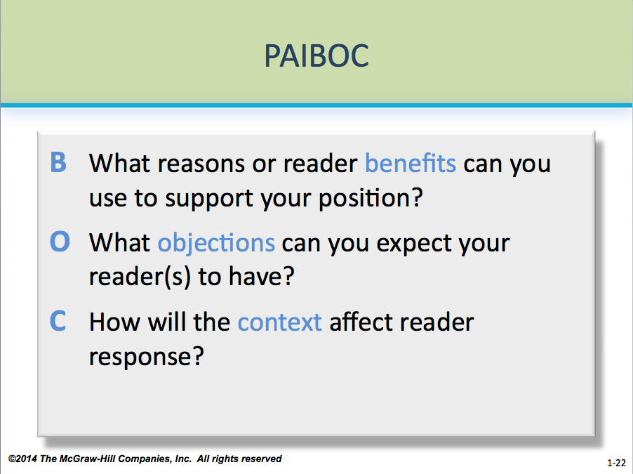**☺** **Teaching Tip:** *Audience* is covered in more detail in **Module 2.** Students should understand that the audience-centered approach to communication will help them create better documents.

**I Information**

**B Benefits**

**☺** **Teaching Tip:** *Reader benefits* is a concept covered in more detail in **Module 8.** For now, help students to understand that in any business transaction, the parties involved look for benefits. Mutual benefits are points of agreement or compromise. To help students understand the concept, brainstorm with them the benefits of taking a business communication course. Encourage them to look beyond simple tangible results—e.g., learning to write specific documents—and also consider less tangible ones—e.g., confidence in business communication situations.

**O Objections**

**☺ Teaching Tip:** Many objections can be overcome—offering an attractive interest rate or a product in a popular color—but others may be impossible—stocking unusual sizes or approving a credit line far beyond what an applicant is qualified for. Remind students to stay within reason when considering both objections and how to overcome them.

**C Context**

For messages throughout this text and throughout their careers, students should use PAIBOC *before* composing messages. The solutions they create for business communication problems must solve both the organizational problem and meet the needs of the writer or speaker, the organization, and the audience.

**Thinking Creatively LO 1-7**

The key to thinking creatively is to think “out of the box,” that is, to shed common paradigms and instead look for innovative ways to approach problem solving. Creativity is essential in business and business communication.

A good example of being creative is the producers of *Adult Swim,* the television program block on the Cartoon Network. Instead of using standard marketing practice that likely would have resulted in yet another tired version of the same kind of programming available elsewhere, the producers instead asked themselves what they wanted to watch—and why wasn’t it on TV already? The result was a ratings success for a network with comparatively smaller resources.

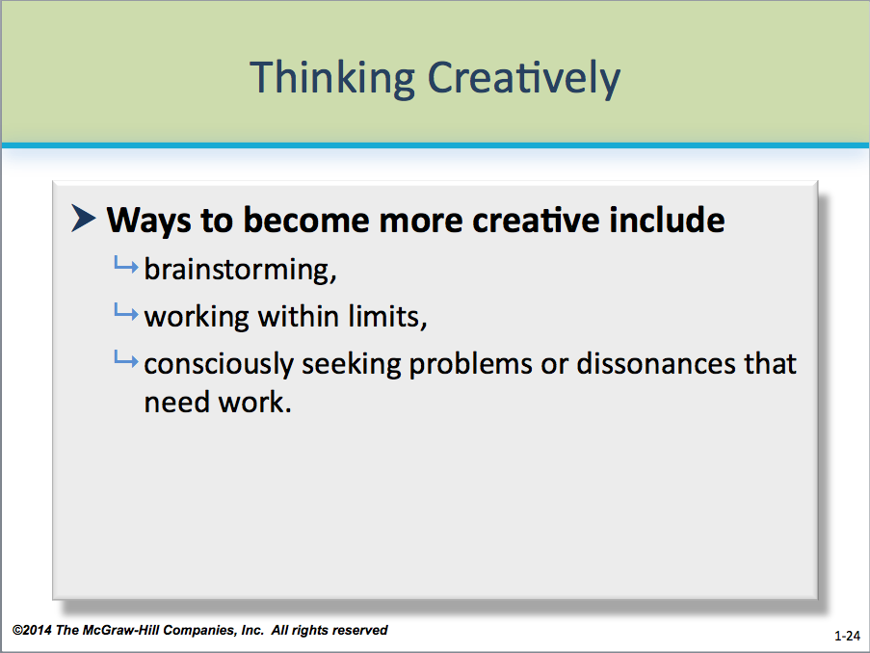Some companies have procedures for employees to be more creative, some of which are described on **PP 1-24.** For instance, IBM suggests:

* Have a constructive argument.
* Brainstorm with someone 10 years older and someone
* 10 years younger.
* Clean your desk.
* Come in early—enjoy the quiet.
* Leave the office. Sit with just a pencil and a pad of paper. See what happens.

**☺** **Teaching Tip:** Many students don’t think about themselves as being creative because they compare themselves to well-known figures, such as artists, musicians, inventors, and entrepreneurs. But signs of students’ creativity can be found immediately, in everything from hobbies to choice of dress to doodling on their notebooks. Help students to see their own creativity by examining their choices and how the choices define them as individuals.

**** **In-Class Exercise:** Teaching someone to be creative is a difficult, if not impossible, task. It’s better to give students the opportunity to apply creative skills and learn through the experience. One exercise that works especially well for kinesthetic learners is to give groups of 3-5 students each a variety of common objects found around the office: a paper towel tube, sheets of copy bond, markers, pushpins, and the like. Then give them 10 minutes to come up with something that represents how the group, the college, or a popular celebrity or product.

** Last Word:** By the end of this module, students should understand the importance of communication in the workplace. Help them to see that good communication skills are needed beyond the classroom and can help them get the jobs, promotions, and careers they want. But first they must see good communication as an integral part of everything they do in business.

**Part 2: Answers to Textbook Assignments**

**Questions for Comprehension**

**1.1 What are the three basic purposes of business messages? (LO 1-3)**

To inform, request or persuade, and build goodwill.

**1.2 What are the five basic criteria for effective messages? (LO 1-5)**

Good business and administrative writing is clear, complete, and correct; saves the reader’s time; and builds goodwill.

**1.3 What does PAIBOC stand for? (LO 1-6)**

Purposes, audience(s), information, reader benefits, objection(s), and context.

**1.4 Why do writing and speaking become even more important as people rise in the organization? (LO 1-1 to LO 1-3)**

As employees rise in an organization, they are likely to have to write and speak more, as well as be responsible for supervising or reviewing the presentations and writing of others. Most organizations expect their managers and supervisors to possess strong communication skills—and demonstrate them effectively in correspondence, meetings, and face-to-face interaction. Though technical skills are important for a job, strong communication skills can help separate an individual from the pack.

**1.5 If you’re just looking for a low-level job, why is it still useful to be able to write and speak well? (LO 1-1 to LO 1-3)**

All jobs require communication skills, and to get a job in the first place, potential employees usually must write an effective resume and job application letter, as well as interview well. Employees who are hired or promoted often demonstrate good communication skills, not just technical knowledge or experience.

**1.6 Why do you need to understand the purposes, audience, and context for a message to know whether a specific set of words will work? (LO 1-2)**

Purpose identifies what organizational problem the message will serve, what it must do to meet the writer’s needs, and what the writer wants readers to do, think, or feel. The audience helps shape the content of the writer’s message, as well as the choice of language and detail. Context helps writers understand the current state of affairs for the organization or audience. Writers must choose words carefully to address concerns for each of these areas.

* 1. **What opportunities do you have in volunteer or student organizations to do real “business writing” while you’re in school? (LO 1-5)**

Students’ answers will vary. Most students will have a multitude of possibilities—campus honoraries, fraternities and sororities, work-study and part-time jobs, internships and co-ops, and charity organizations are just a few. Students may also have personal correspondence—with banks, landlords, auto dealers, and the college or university—that could qualify as business correspondence.

**1.8 Discussing Strengths (LO 1-5, LO 1-6)**

This in-class problem invites students to share strengths. It’s good if you’ll be using collaborative groups, since people can begin to learn what others’ strengths are. It also works well if you will be teaching the job unit early in the course.

**1.9 Introducing Yourself to Your Instructor (LO 1-5, LO 1-6)**

This assignment is straightforward. Kitty and Steve like it because it helps them see students as individuals and as competent people. Many of them who are not good writers nevertheless have impressive achievements in other areas. Because people going through rough periods may not be ready to write about themselves, Kitty often gave students a choice of either this or **Exercise 1.12.** Steve also likes the assignment because it gets their “feet wet” regarding document format.

Take 10 minutes to tell students to

* Use a complete memo format; remember to initial the memo. Headings are optional.
* Include only information they feel comfortable sharing.
* Be specific enough to show how they’re different from other people who are from the same town, in the same major, planning the same career path.

List *at least five* accomplishments. These can be anything that makes the writer feel good about himself or herself, even if it’s not the kind of thing that goes on a résumé. For example, someone who has just run a 10K race for the first time may justly be proud of that, even though other people run further or faster.

Your students may write better memos when you give them a memo about yourself. (They also enjoy learning something about you, just as you will enjoy being able to see them as individuals.) Use **Appendix 1-A through Appendix 1-C** as an example of one of Kitty’s introductory memos.

You can use **Exercise 1.10** as an in-class discussion exercise to help students prepare for this assignment.

If you use this problem, point out to students that it is very different from other assignments they’ll have. Kitty has had students who have done very well writing about themselves and very poorly when asked to assume the roles of middle managers. The opposite also happens: some students who write vague, stilted memos about themselves do just fine in the course.

**1.10 Describing Your Experience in and Goals for Writing (LO 1-5, LO 1-6)**

This assignment tells you what your students already know about writing and can help you plan the course.

Usually the very best writers will produce strong responses to this prompt. Mediocre writers have problems. They often aren’t conscious of what they’ve been taught or of how their writing has been evaluated—they remember only the grade, not comments. They may not have enough awareness of labels or of the kinds of areas in which writing is evaluated to know what they see as strengths and weaknesses. However, even if their view of strengths and weaknesses is off, you may still want to know what they see as their strengths and weaknesses.

**1.11 Letters to Angry Electric Company Customers (LO 1-5 to LO 1-7)**

**Letter 1**

The salutation is impersonal and shows lack of interest on the part of the writer, who should determine whether Harper Henry is a man or woman.

The letter lacks you-attitude and does not address the writer’s concern about power outages and their impact on people’s everyday lives.

Good messages should always be complete, answering all of the writer’s questions. This letter is merely a form letter and provides little or no information to the letter writer.

Because we are not giving the reader what she asked for—or even supplying specifics—the reader will be unhappy with the response.

**Letter 2**

The salutation is too informal.

The style is too informal. The humor doesn’t work.

The letter doesn’t specify what the Electric Company plans to do regarding outages in the future.

The letter lacks you-attitude and admonishes the reader about what she should do differently.

**Letter 3**

The courtesy title assumes that “Henry” is the writer’s married name, which it is not.

The tone of the letter is condescending and lacks you-attitude. Detailing the union rules that impact the Electric Company’s business strategies is inappropriate and does not address the reader’s concerns.

**Letter 4**

Of the four sample letters provided, this one provides the most effective message. The letter meets the five criteria necessary for good messages: It’s clear, complete, and correct; saves the reader’s time (and provides pertinent information about the outages); and builds goodwill, presenting a positive image of the writer and his or her organization.

**1.12 Online Messages for Discussion: Responding to Rumors (LO 1-5 to LO 1-7)**

**Message 1**

The subject line is vague.

The first paragraph emphasizes the writer’s role, rather than stating what readers need and want to know: how they will be affected by the merger.

The second paragraph contains negative references and blames readers for the rumors that are circulating.

Even the last paragraph sheds no new light on the effects of the merger on employees. As a result, rumors are likely to increase rather than decrease.

**Message 2**

This memo gives too little information. The subject line is not specific, and the body of the memo offers no details to make “no layoffs” seem credible. For the rumors to stop, employees must be reassured—by hard information from someone they trust—that their jobs are not in jeopardy.

**Message 3**

The subject line does not inform readers.

The first paragraph gives too many details too soon, de-emphasizing the main point: no layoffs. It’s unfriendly. Placing the supporting details in a second paragraph and omitting the sarcastic “if you do the math” would improve the message considerably.

The second paragraph gives readers two reading assignments without explaining why or what employees are to derive from the assignments. The writer might have cited passages of Acme’s mission statement and goals to reinforce his no-layoffs message.

**Message 4**

The subject line sets a negative tone for the message.

The first paragraph contains a grammar error, which seems minor compared to the harsh tone. It omits information designed to reassure employees and quell rumors about layoffs.

The second paragraph lacks you-attitude. It, belatedly, contains the *main message*: “. . . we won’t be laying off employees after the merger.” But the extremely negative, disrespectful tone makes the statement seem insincere. The paragraph shows ill will toward employees, rather than goodwill.

The third paragraph continues to scold employees—and undercut any trust between them and the writer.

**Message 5**

The subject line is acceptable, though “Layoffs—the True Story” would be better in case the readers’ screen displays fewer than the 28 characters in this line.

The first paragraph has an understanding, neutral tone; but since the main message (no plans to lay off any of our valued people) is positive, it should appear here instead of in the second paragraph.

In the second paragraph, although the writer wants to reassure employees, “Have no fear!” is inappropriate. Much of this paragraph belongs in Paragraph 1. The writer could have increased you-attitude by writing himself out of the picture and by stressing that updates will appear in the newsletter and on the intranet *at regular, predictable intervals*.

The third paragraph could be more positive and forward-looking. “Our people” is patronizing. And the writer issued an open invitation to bombard him with all sorts of questions.

**Polishing Your Prose: *Sentence Fragments* (Odd-numbered answers are in the back of the textbook.)**

*Several answers are possible*—*here are likely ones.*

2. Diane downloaded the latest word processing app.

4. Because he will be in Portland for the day, Terrence will miss the staff meeting.

6. Whenever Joyce gets a chance to review the file, she will share her thoughts with the CEO.

8. James Jefferson has more than 20 years of IT experience, including consulting assignments overseas.

10. Certain the manufacturing license will be granted by July 2, Chloe issued a press release to the media announcing the new product.

**Part 3:**

**Appendix 1-A: Memo of Introduction**

September 20, 2000

To: Business Communication Students

From: Kitty O. Locker 

Subject: Kitty O'Donnell Locker on September 20, 2000

I'm looking forward to this quarter. I'm ending three years as a journal editor, and I hope to have time not only to teach well but also to do some of my own work and plant bulbs. I may not get all of that done, but I'm looking forward to ending a responsibility that has made life almost impossibly busy. I feel more relaxed than I have in a long time.

**Background Information**

I was born in Wyoming, grew up in Kentucky, attended DePauw Uni­ver­sity in Indiana, and did my graduate work at the Uni­versity of Illinois. After earning my PhD, I taught at Texas A&M University for a year and at Illinois for seven years before coming to Ohio State in 1985. In 1990, I received tenure and promotion to associate professor.

Although I got into business communication by accident, I have stayed in it by design. The field has been good to me. I've been very active in the Association for Business Communication; my textbook, *Business and Administrative Communication,* is the number 1 book in the United States. My research areas include the history of business communication, negative messages, collaborative writing, and the writing of factory workers. In January 1999, I finally published a project that I began in 1976 on reader responses to negative messages. My other decades-long project is a study of the corres­pondence of the Brit­ish East India Company (1600-1858). In *The Development of the Faceless Bureaucrat*, I trace the evolution of bureau­cratic writing in the first two cen­turies of the Company's correspondence and argue that the basic causes of bureau­cratic writing are psycholog­ical, not rhetorical. I laid the East India project aside (not for the first time) to work on another textbook that will come out this December. But in 2001, I actually hope to finish revising the East India book and get it off to a publisher. I'm finishing three years of editing *The Journal of Business Communication* (JBC), which has been satisfying but very time-consuming. I'm looking forward to doing some of my own work.

I've been fortunate in my personal life, too. In August, Bob Mills and I celebrated our 19th wedding anniversary (in Nikko, Japan--a beautiful place). When I met Bob (in a disco dance class!), I was divorced and felt dubi­ous about marriage.  With Bob, I've learned that a man and a woman can communicate openly, that conflicts can be res­olved, and that reso­lution produces intimacy.  In a world with so many un­happy marriages, I feel fortu­nate to be part of a strong one. I don't believe that people need to confront the world in matched pairs, like bookends, but it feels very good to love and be loved and to be part of a learning, growing, sup­portive relationship.

We spent the first year of our marriage in tiny Homer, Illinois, where Bob was pas­tor of the Presbyterian church. Then Bob decided to pursue a min­istry in "underdog law." His second career was as an attorney with Ohio Legal Rights Ser­vice (OLRS), a state agency which repre­sents people who are mentally

**Appendix 1-B: Memo of Introduction**

Business Communication Students 2 September 20, 2000

handicapped in civil suits. He's now reinvented himself again, as a computer network administrator for OLRS. He got this new job without going back to school, without job hunting, and without losing pension benefits. He loves his work.

When we married, we each had two cats. Four years ago, the last two died (at the advanced age of 18½). We now have just two cats in our second generation of cats. Honey-colored Webster is the neighborhood charmer. He likes small children and knows more people in the neighborhood than we do. One year a group of people came to our house to sing Christmas carols to *him.* Liza is solid black. She is more of a home body than Webster. She was so scared when we brought her home from the shelter that she slept in the ceiling of the basement for months. But over the years she's turned into a pet.

In 1989, I went in for a baseline mammogram and discovered that I had breast cancer. I had a lumpectomy and radiation. Six years ago, I had a recurrence, a mastectomy, and six months of chemotherapy. I feel much more charitable about the chemo now that it's in the past and I'm fine and can do what I want to do.

**Personality and Beliefs**

In some ways--not all--I'm very independent.  I can become very enthusiastic about ideas and people.  I'm an ardent feminist, though there are definitely spots where my consciousness isn't as high as it could be and I enact sex-role stereotypes.  Bob is also a feminist. Many years ago, however, we aban­doned our early effort to split the cooking evenly: I do all the cooking and Bob washes all the dishes. We pay to have the house cleaned. What a pleasant luxury!

Although in some areas I'm a traditionalist, I'm a liberal on most issues, partly as a result of living with Bob. I'm also de­veloping a sense of humor. I actually emceed a roast a few years ago for a retiring col­league and had the audience rolling with laughter on the last joke. (To be fair, it was one I'd heard the roastee tell. But my timing was exactly right.)

I complain about having too much work to do (and I overcommit my time), but I like being busy and I like doing projects that seem worth doing. When one project ends, I take on two more. I don't call myself a workaholic--for one thing, I love to goof off, too--but for the last dozen years I've acted like one!

**Interests**

Many of my interests are long-standing. I like houses and decorating and gardening. Each spring, we start some annuals and vegetables from seed in the basement under grow lights. I like OSU basket­ball, expecially when we win. I like organ and harp­sichord music and medium-hard rock. I like representa­tional paintings, traditional ballets, and cheerful movies. I read science fiction and non-violent murder mysteries (I like puzzles, not gore). I can appre­ciate modern and abstract art but I'm fondest of Impressionist paint­ings. Visits to Florence and Rome have made me really appre­ciate Re­nais­sance fres­cos and everything by Michel­angelo. Photo­graphs of his statues and the Sistine Chapel just don't mea­sure up to the reality.

**Appendix 1-C: Memo of Introduction**

Business Communication Students 3 September 20, 2000

Bob and I like trav­eling‑-to state and national parks, US cities, Williamsburg, Disney World, Europe, and, most recently, Japan. When my professional conferences are in neat places, we ­try to spend a few days before or after the con­ference exploring the city. I had a conference in Kyoto this summer, and we spent

two weeks touring Japan. (We got around fine, even though we don't read or speak Japanese. People were very helpful.) Two years ago, we spent three weeks driving through Germany, Austria, and Belgium with my brother (who lives in Scotland and speaks German); we visited Bob's sister who was in Brussels at the time. She now lives in Africa, and perhaps someday we'll visit her there.

In 50 years, I've had the opportunity to do many things.  The accomplish­ments which please me most at this point are

1. Building good communication and problem-solving strategies in my relationship with Bob.

2. Playing Titania in a college production of *A Midsummer Night's Dream*.

3. Being a friend and having good friends.

4. Feeling that the English department at OSU has accepted me and (per­haps) is even beginning to accept business writing as a legitimate academic disci­pline.

5. Advising graduate students, and having both of my students on the job market last year get tenure-track jobs.

6. Being the only person (so far) to receive both the "Outstanding Researcher Award" and the "Outstanding Teacher Award" from the Association for Business Communication.

7. Helping a man at a local company go from being a "terrible" to an "excellent" writer, in the judgment of his supervisor.

8. Having people come up to me at conferences and tell me that they really like using BAC.

**Goals**

In October, I'm giving a series of talks in Finland, and I need to prepare those presentations. I'd really like to write two articles this quarter if I can. I need to finish up the remaining work on JBC. I also want to teach well, get back on a regular exercise schedule, give some energy to my marriage, and, if time permits, plant lots of spring bulbs.

Five years from now, I hope that *The Face­less Bu­reau­crat* will be in print, that both my textbooks will be doing well in their respective markets, and that I'll be a full professor.

This term should be busy and satisf­ying. I look forward to working with you and to a productive quarter!